FINAL PROJECT REPORT

AJ3: Innovative Solution for Reducing Non-Faecal Load in WWTPs
Sponsored by: SMEC

Sponsor’s name: Hajari Singh Thakur
Mentor’s name: Tina Golkhou
Team members:
Neelesh Bhujoo | Thomas Power | Alexandra Bollweg
Sophie Westcott | Joyal Jojo | Navroop Singh Goraya

Executive Summary 3
Team Profiles 4
Project Journey and Methodology 5
Phase 1 Research 5
Phase 1 Interviews 5
Phase 1 Ideation 6
Phase 2 Research 6
Phase 2 Interviews 7
Phase 2 Ideation 7
Final research and validation phase 7
Summary of Data 8
Desktop Research 8
Interviews 9
Final Solution Feasibility Research 9
Key Insights 10
Proposal 12
Value created 14
Measuring Success 15
Next Steps 16
Team Reflections 18
Appendices 19
Appendix A – Interview Data 19
Appendix B - Recipes and relevant calculations 21
Appendix C – Summary Data 23
Appendix D – WWTP Operational Costs 25
Appendix E – Weighted Criteria Matrix 26
References 27

Executive Summary
This project investigates strategies to minimize the disposal of fats, oils, and grease (FOG) in residential and commercial kitchens, which contributes to significant issues in wastewater management. Sponsored by SMEC and led by a team of multidisciplinary students, the project aims to develop sustainable and efficient solutions to improve the operations of WWTPs by addressing the root causes of fatberg formations and high energy consumption.
The primary focus is on reducing the amount of FOG entering wastewater systems from kitchens, particularly in culturally diverse communities where cooking practices often involve high oil usage. The project team conducted extensive desktop research to understand the impacts of FOG on sewer systems and WWTPs as well as interviews with Melbourne residents to understand the FOG preparation, cooking and disposal habits.
Key insights from the research revealed that cultural cooking practices, especially within Chinese communities, contribute to a higher volume of FOG in wastewater. Many residents were unaware of proper FOG disposal methods, leading to improper disposal and increased fatberg formation. In response, the team developed a solution to distribute illustrated paper towels with instructions on proper FOG disposal. This innovative approach encourages behavioral changes by making it easy for households to wipe and discard oil residues in FOGO bins, thus preventing them from entering the wastewater system.
The proposed solution is expected to significantly improve WWTP efficiency, reduce operational costs, and promote sustainable water management practices across Melbourne. The pilot project, targeting the Whitehorse Council, aims to save a significant amount in WWTP annual operational costs. Through using Eastern Water’s available data, we were able to estimate an approximate $300,000 per year reduction in WWTP operational costs, and reduction in CO2 emissions by approximately 100 tons. Our proposal will contribute to the broader environmental goals of SMEC and local water authorities. Through this initiative, the project demonstrates how simple, yet targeted interventions can have a lasting impact on environmental sustainability and public awareness.


Team Profiles
Thomas Power - I grew up in Kyneton, a small town in rural Victoria but completed my Bachelor of Commerce majoring in Economics and Finance at the University of Melbourne. I’ve begun a Master of Environmental Engineering this year due to my interest in contributing to positive environmental outcomes, particularly through finding new and innovative decarbonisation strategies.
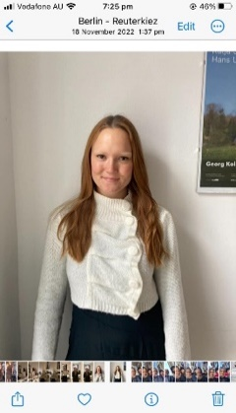
Sasha Bollweg - I grew up in Melbourne, Australia, and completed my undergraduate studies in New York, USA, graduating with a Bachelor of Science in Chemistry. I have worked as a Laboratory Technician at an environmental testing laboratory and developed a keen interest in the holistic approach to environmental solutions which led me to pursue my Masters of Environmental Engineering at University of Melbourne.

Neelesh Bhujoo - I am studying mechanical engineering. I grew up on a small island called Mauritius and did a Bachelor of Science majoring in biomedical engineering at Unimelb. Throughout my studies, I have developed a strong interest in ways to research and create novel solutions that positively impact the environment. I have further developed my analytical and conceptual design skills around user centered design through this project.

Sophie Westcott - I am currently studying a Master of Environmental Engineering after completing a Bachelor of Science at the University of Melbourne. I’ve always lived in Melbourne but am passionate about travel and recently have spent time exploring Europe and China. I’ve had experience working at two environmental consulting firms, which has helped me discover a great interest in working on developing environmental solutions.

Joyal Jojo - I'm studying for a master's degree in mechanical engineering. I'm originally from Kerala, India, and completed my undergraduate degree in mechanical engineering from NIT Calicut, India. I have diverse experience as an engineering intern at Hindustan Aeronautical Ltd and Technical Consultant at PWC. I am actively involved with students in the Renewable Energy Club at the University of Melbourne.

Navroop Singh Goraya - I am studying for a Master of Chemical Engineering. I have done my undergraduate in chemical engineering from India. I have worked as an Engineer managing the production of Polypropylene polymer. My Research paper on Coal Bed Methane was published in a highly reputed journal and my project on Carbon Capture is filed for patent. I am very curious by nature and seek to enhance my skill set.

Project Journey and Methodology
Background research was undertaken for this project in two phases: an initial phase of broad research on the topic, and a second phase of more specific research as we approached our final solution. Interviews were also conducted through two phases: the first phase being a broader target of people, and the second phase targeting our segmented group for our solution. These waves of research are illustrated in Figures 1 and 2 below.

Phase 1 Research
The initial phase of background research focused on getting a deeper understanding of:
- Fats, oils and grease (FOG);
- Types of food/oil fat compositions and how easily they congeal on pipes;
- Fatbergs - how they are formed, main causes, environmental effects, cost of removal;
- Current solutions that are in place for minimizing incorrect domestic sink waste;
- FOGO bins, collection and differences in council rollouts; and
- International examples of fatberg awareness and reduction campaigns.

Phase 1 Interviews
Thirty-five (35) interviews were conducted with a diverse group, ranging from 18–60-year-olds. This group comprised individuals who lived in a family dynamic, as well as individuals renting and cooking primarily for themselves.
The purpose of the phase 1 interviews was to broadly understand:
- General kitchen habits;
- The sequence of events in the kitchen that lead to waste disposal (grocery shopping, preparation, cooking, cleaning);
- Any inconveniences that interviewees experience in the kitchen;
- Awareness of fatberg build up in personal pipes or in Melbourne;
- How they dispose of their FOGs (fats oils greases); and
- If they currently use a FOGO bin.
Additionally, 1 commercial kitchen owner was interviewed to understand the management practices at a commercial level. This was then removed from the scope but was used as extra insight into the problem.
After the data was collected, it was analysed through grouping similar responses from interviewees to generate collective key insights into kitchen FOG disposal and understand different reasons why people dispose of FOGs differently. This led us to our phase 1 ideation.

Phase 1 Ideation
This process included brainstorming initial prospective solutions, worst idea process, temporal sequencing on the basis of insights gathered from interviews and desktop research. These ideas were split into behavioral (school awareness program) and technical (mechanical filter) solutions, in which feasibility, viability and value creation was compared and weighted, narrowing down our path of focus to conclude phase one.
From the phase 1 interviews, we found that high oil and fat usage was present in some cultural groups more than others, for example in Chinese cooking culture. This led us to conduct phase 2 desktop research into investigating which cultural groups use large amounts of oil in their cooking, as an indication of how to narrow our focus to find a smaller target group for a more impactful solution.

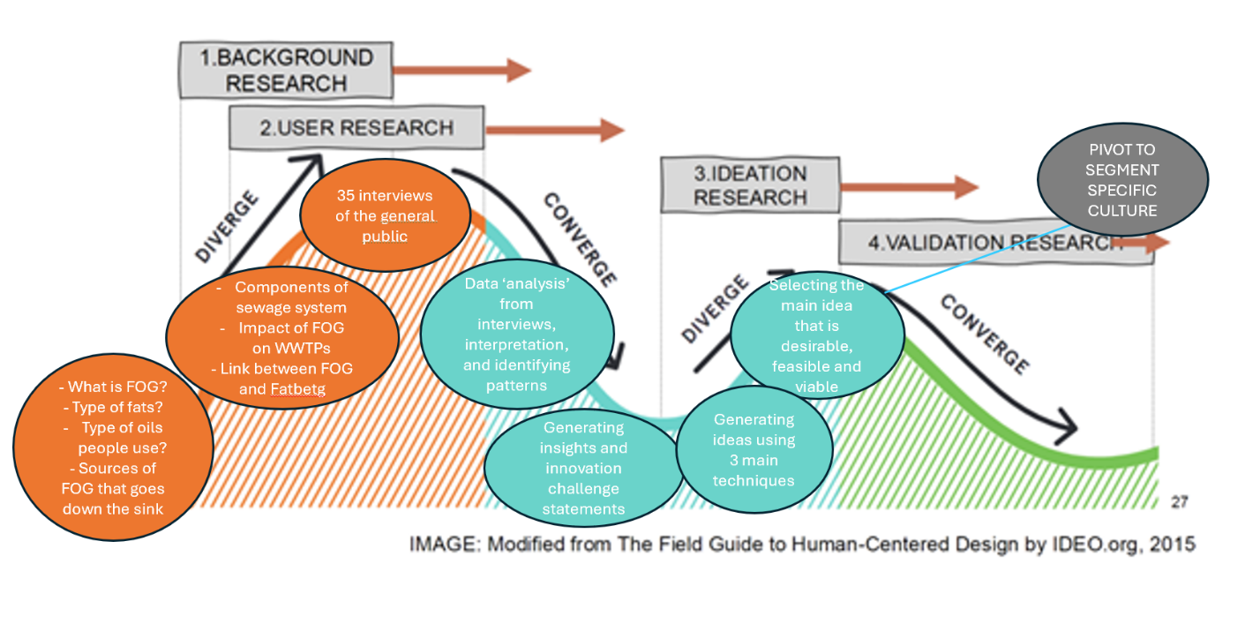Figure 1: Phase 1: four waves of research diagram, mapping out the research steps taken.

Phase 2 Research
Based on the findings from Phase 1, we conducted confirmation research in comparing Chinese cooking culture to other cooking styles to confirm our observations and understanding of high oil use in Chinese style cooking. We narrowed our focus and segmented our target group to Chinese culture and kitchen habits in Melbourne. We undertook research into where large Chinese communities live in Melbourne, to identify where to target our solution. Further research was then done into:
- Whitehorse city council website and relevant recycling guidelines;
- Understanding common Chinese style dishes and how they are cooked;
- Examine ethical considerations when segmenting to one culture and where similar practices have been successful and ethically sound; and
- Maintenance costs for Eastern Water WWTP and fatberg removal costs.

Phase 2 Interviews
Thirteen (13) interviews were conducted with Chinese people living in Melbourne, as we narrowed our solution focus to one cultural group. The purpose of these interviews was to understand:
- The journey of how oil and fat is used and disposed of during cooking Chinese meals;
- What are common Chinese dishes that are cooked in Melbourne to apply in the marketing strategy for the target audience; and
- The main types of oil that are used in cooking.

Phase 2 Ideation
We pivoted from some of our phase 1 ideation solutions, since we knew we wanted to make it more specific and targeted towards a single council group (Whitehorse) to a certain culture (Chinese). We took our idea of creating a behavioural change in the community, and discussed from our learnings that providing individuals with a physical product would encourage them to form a habit would be the most effective way to create habitual change. This led us to the innovative idea of designing paper towels with illustrative instructions in how to clean up FOG waste and dispose of it correctly.

Final research and validation phase
- Understanding marketing strategies in councils; and
- Paper towel branding strategies; and
- Researched ways to measure success of solution and FOG within Whitehorse Council sewerage network and at WWTP inlet via sensors, sample taking and costs involved.

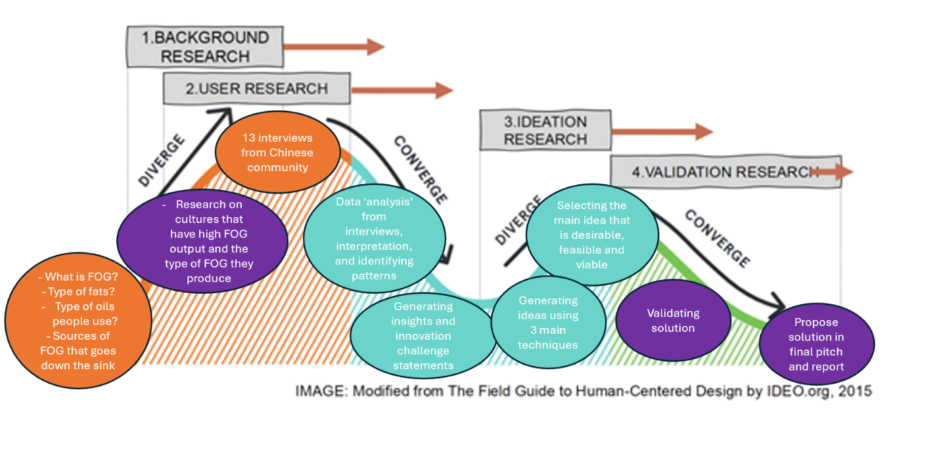Figure 2: Phase 2: four waves of research diagram, mapping out the steps taken.

Summary of Data
Through comprehensive background research and interviews, a range of data was collected to understand the scope of the project.

Desktop Research
Desktop research allowed us to understand more about FOGs, their composition, household kitchen practices, food organic garden organic (FOGO) bins and Chinese cooking style. We found that saturated fats are usually solid at room temperature, oils are liquid but become solid at low temperatures, and grease is a general term involving both. When FOG is disposed of down kitchen sinks, FOG can solidify inside pipes, leading to blockages, and sewer backups which can lead to sewer overflows. In Australia, it is estimated that fatbergs sewer blockages cost up to 15 million dollars per year (Eco Guardians, n.d). Table 1 in Appendix C summarises some key statistics of FOG in residential kitchens.
We found that FOGO bins work in parallel with what we were trying to achieve, since they can take paper towels and oil waste, which get reused and contribute to a circular economy. Importantly, we found only 59% of local government councils in Victoria offer FOGO collection – as of August 2023.
We found that the mean amount of cooking oil used per 100 g of raw food materials in Chinese cuisine was 8.1 g (Pu et al., 2019). However, on the whole, more cooking oil was used in hot dishes than in cold dishes, and more oil was used in meat dishes than in pure vegetable dishes.

Interviews
The key data that was gathered from the interviews included:
- FOG waste was disposed in multiple ways, including kitchen sinks, FOGO bins, landfill, gardens and collected in containers;
- Awareness levels of correct disposal methods for FOG waste varied from no awareness, partial awareness and full awareness, with more participants being partially or unaware; and
- A large majority of interviewees were curious and interested in adopting a solution to ensure they were correctly disposing of FOG waste.
A summary table is displayed in Appendix A with the detailed statistics from the interviews.

Final Solution Feasibility Research
To ensure viability and feasibility of our solution, detailed research was undertaken into our target group of Whitehorse Council and its respective treatment plant (Eastern Treatment Plant). As of 2023, there are 178,639 residents making up roughly 71,000 households in Whitehorse Council as summarised in Appendix C Table 2 and 5.
Additionally, we compared alternative successful awareness programs to ours and completed cost analysis and projections for our solution. This found a 26% sewer reduction and a 70% change in behaviour when exposed to the awareness campaign due to the ‘Bin it, don’t block it’ campaign after four years in the UK, detailed in Appendix C Table 3.
Eastern Water, the WWTP that Whitehorse Council sewerage goes to, treats 400ML/day, costing roughly $58 million AUD per year in operational costs (see Appendix C Table 4). Efforts made by one council to reduce FOG blockages by 26% will lead to an approximate $300,000 yearly saving for Eastern Water. Additionally, the greenhouse gas emitted from WWTP will be reduced by roughly 100 tons of carbon dioxide equivalent per year.
The paper towel manufacturing and delivery costs will equate to roughly $250,000 as detailed in Appendix Table 5.

Key Insights
During the first phase, we conducted extensive research to understand the core issues surrounding FOG disposal, its sources, and its impact on wastewater systems. We explored how FOG contributes to fatberg formation and its implication on the sewer networks across Melbourne. We understood that the improper disposal of FOG is the starting point for the formation of fatbergs as it acts as a binding component when combined with other waste products such as wet wipes can form a massive lump and cause costly problems.
After our desktop research, we then investigated the residential FOG disposal practices of the public and looked at how factors such as cultural practices, age, or where people live have an impact on the way they dispose of FOG. We observed that many residents are unaware of the proper disposal methods for FOG, with common misconceptions leading to improper disposal regardless of age. We also learned that certain cultures tend to produce and dispose of higher FOG content than others. Living conditions such as renting or owning a house were also important factors to consider as renters tended to be less concerned with pipe blockages as they are not fronting the cost. The first phase of interviews showed that Chinese cuisine had produced relatively higher FOG content and further research during phase 2, looking at how cultural dietary habits influence FOG generation made us select this segment as a key demographic. Comments made such as “I cook with a lot of fat and oil, especially pork and meat fat”, and “I use a lot of oil for deep drying”, solidified this insight for us. Cooking journeys were also spoken of, for example one dish of Kung Pao Chicken was outlined by one interviewee, where chicken thighs and oil were purchased, then the chicken skin was cut and thrown into the general waste bin during preparation as using a FOGO bin felt inaccessible and complicated. Additionally, excess oil was washed down the sink after cooking, and bones were thrown in general waste. This highlighted that people underestimate the impact of small oil amounts on pipes and wastewater treatment plants (WWTPs), wrongly assuming dishwashing liquid mitigates the effects. This journey highlights the need for education on FOG disposal and quick, easy methods to prevent FOG from going down kitchen sinks.
During Phase 1, we also interviewed 1 fish and chips shop to understand FOG management practices in commercial kitchens where strict regulations, such as requirements for grease trap installation and regular maintenance, are put in place to lower the amount of FOG that ends up down kitchen sinks. The technologies being used in commercial kitchen such as grease traps, effectively separate fats, oils, and grease from going to wastewater, preventing blockages. In these settings, consistent enforcement of regulations, alongside staff training on proper disposal methods, plays a crucial role in maintaining the effectiveness of these systems.
With the data we gathered, we grouped it thematically to be able to interpret its importance. The key theme that we focussed on after gathering data was ‘lack of awareness’. To interpret this data, we were guided by asking several sequential why’s to generate insights, such as:
- Why do people not dispose of FOG correctly at home?
- Why do people find oil disposal difficult, or are lazy with it?
- Why aren’t FOGO bins sufficient or desirable?
- Why haven’t councils jumped on this issue more?
Despite commercial kitchens not being in the scope of our project, we drew insight into their FOG management practices as it answered our sequential whys. Specifically, it highlighted the importance of education, where kitchen staff are regularly trained on how to handle FOG properly, and technology, where grease traps and interceptors ensure FOG is collected and disposed of responsibly. This led us to examine how to apply either mechanical and/or educational and awareness to a residential scope where both methods are lacking.
Consequently, we drew insight into how we could adapt these principles to residential contexts to develop simpler but effective FOG disposal tools, educating the public about the environmental impacts of improper FOG disposal, and creating community-level regulations or incentives to encourage proper waste management. For instance, just as restaurants are required to maintain grease traps, residential programs could introduce FOG collection containers and disposal services, supported by public awareness campaigns that stress the importance of keeping FOG out of household drains. Additionally, local councils could provide clear guidelines and potentially impose penalties for improper FOG disposal to ensure compliance. The integration of these elements could significantly reduce the amount of FOG entering residential sewage systems, lowering the risk of fatbergs and related sewer issues.
Ultimately, a lack of awareness of the issue was what we discovered to be the biggest issue with the largest potential for change to be made at a cost-effective scale. This is what led us to exploring the behavioural change pathway, particularly segmenting to the area in which there is a concentrated Chinese population in Melbourne. This segmentation was to ensure a maximum impact for a trial solution as a narrower scope is both more feasible and viable and can be replicated with success. A key insight gathered from observing current marketing geared towards specific cultures, such as posters in toilets showing appropriate seating, was the ethics surrounding implementation of targeting one culture’s practices while remaining culturally aware and unbiased. We recognised that a success within one key demographic could solve similar issues among other cultures and groups.
Our insights gathered led us to a series of ‘how might we’ solve the problem of incorrect FOG disposal within the Chinese demographic leading into to our proposed solution, such as:
- How might we make FOG disposal attractive for FOGO bin users?
- How might we engage residents in our awareness program?
- How might we create a lasting habitual change?

Proposal
The research, interview and insight process led us to consider multiple solutions, such as implementing a mechanical filter in kitchen sinks, primary school awareness classes or a new oil collection and transfer service. However, through a weighted criteria matrix, as shown in Appendix E, the solution we found to be the most highly weighted was found to be the most efficient, user friendly and cost-effective.

Our proposed idea is for SMEC to advise their WWTP clients to liaise with local water authorities dealing with Whitehorse Council, to pay for and distribute one illustrated paper towel roll per household to encourage paper towel absorption of FOG during various cooking and cleaning stages to Whitehorse Council residents. The paper towels will have illustrations, in instruction form, of common cooking processes where FOG is commonly disposed incorrectly, from trimming fat of meat disposal in a FOGO bin, to wiping the frypan’s sauce and oil residue with paper towels into a FOGO bin. Figures 3 and 4 show prototype illustrations of what we imagine to be printed onto the paper towels. Our key insights found that there was little awareness on the correct methods of disposing of fat, oil and grease during different stages of cooking. Also, despite many people having access to FOGO bins through their councils, they were not aware that FOGs could be disposed into them through paper towel absorption.

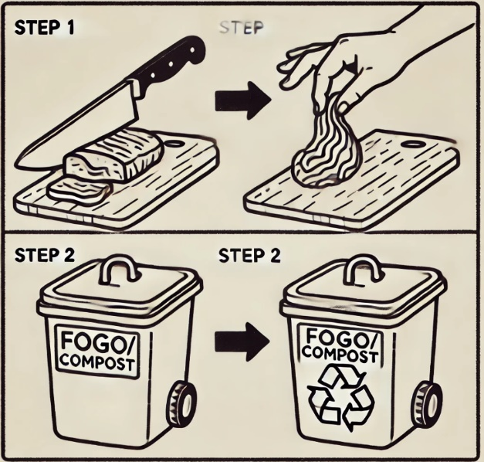
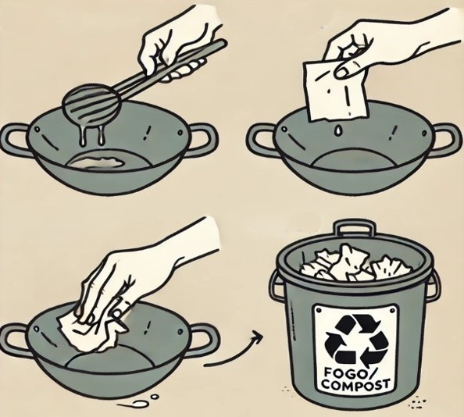
Figure 3: Sample images that could go on the paper towel, showing correct clean up and disposal of the fat and oil waste after cooking.
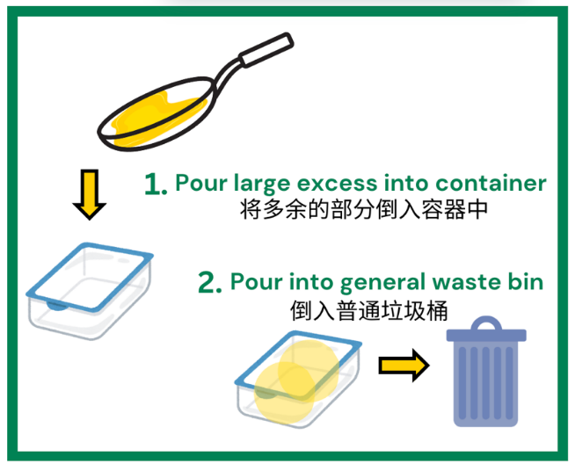
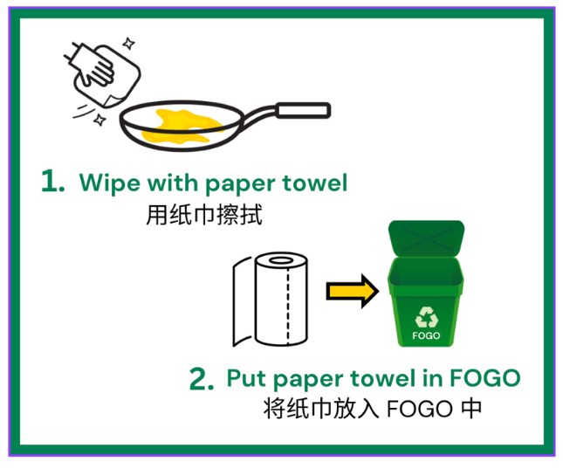
Figure 4: Prototype illustrations with English and Mandarin instructions as subtitles.
We have researched that marketing through illustrations is more effective than just through words, and that it takes roughly 30 days of repetitive ‘doing’ to build a habit. One paper towel roll generally lasts a month, and it is our belief that after observing the proper FOG disposal in various cooking and cleaning stages through infographics, Whitehorse Council residents will be more inclined to use paper towels after using oil in a pan/wok/dish moving forward. This will reduce the amount of FOG disposal entering waterways from the Whitehorse Council.

Value created
Through providing a means of appropriate FOG clean up and disposal via free paper towel delivery, users will have an improved cooking preparation and clean up experience with the knowledge and satisfaction they are doing right by the environment and their pipes. Current water bills paid are fixed payments accounting for operation and maintenance fees of pipes and sewerage network not necessarily the water provided, and with the success of this proposed solution, these fees will reduce for each household. Additionally, council groups are influenced by one another’s successful campaigns, so if Whitehorse can successfully reduce their council wastewater load to the treatment plant, it is likely that other council groups will follow which will increase their reputation for future projects and campaigns.
This idea creates value for the WWTP and water authorities as this behavioral adjustment plan will replicate reductions in fatberg development, as seen in the UK through an alternative awareness program, ‘Bin it, Don't Block it’ in 2013 as referenced in Table 2 in Appendix C. Table 3 in Appendix C detailed the operational and maintenance costs associated with fatberg development, as well as the projected reduction in frequency and cost for water authorities of a comparable size to Whitehorse. Our idea will ultimately save WWTP maintenance costs of approximately $300,000 per year. Additionally, a key challenge that this idea is targeting is WWTP carbon footprint, as there is heavy pressure to meet 2030 emission targets. Currently, medium sized WWTPs emit approximately 7,000 tons CO2 equivalent emissions (CO2eq), as detailed in Appendix C. Through our proposed solution, approximately 100 tons CO2eq will be saved by the Whitehorse Council. In reducing inlet FOG flows through behavioral change, our solution will reduce energy consumption required at WWTP.
Through successful marketing, our idea aspires to create long-lasting reduction patterns in FOG disposal, as it will lead to habitual change in the kitchen. Ultimately this will save the council and WWTP costs and energy consumption involved in sewerage blockages and treatment not only after four years, but continually. Additionally, habits formed are generational as families raise and expose children to their methods and learnings.
Lastly, our sponsor SMEC, through facilitating this solution with their WWTP clients, will stand out as a leading consultancy firm for approaching current environmental issues through a societal and behavioral lens as opposed to a strictly technical solution. Notably, SMEC will have addressed client issues ahead of crisis through understanding the root societal and behavioural cause. This is illustrated in Figure 5 below.
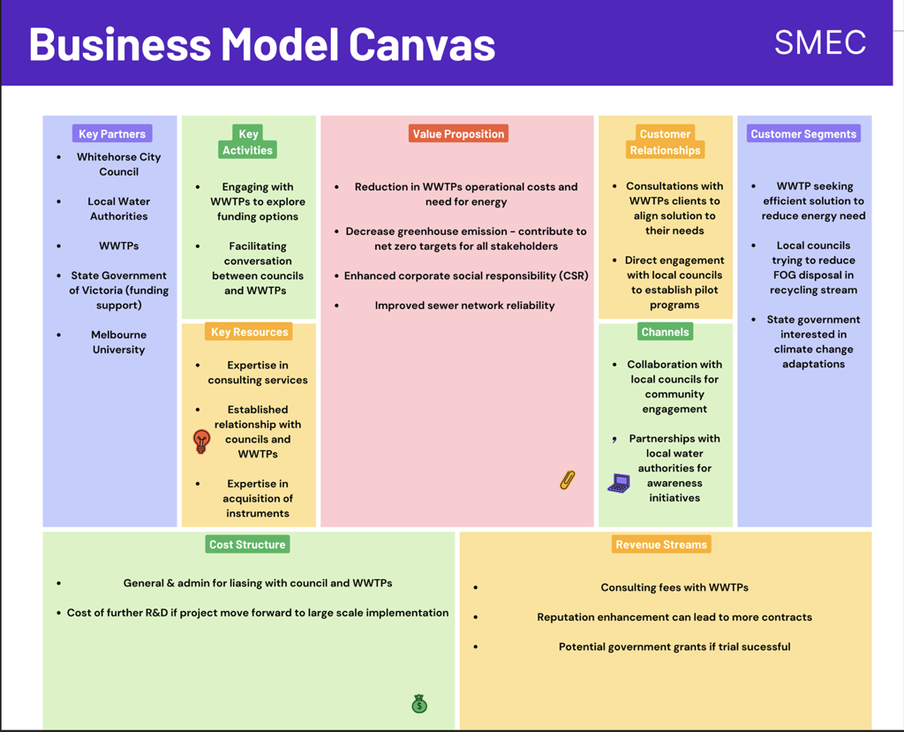
Figure 5: SMEC Business Model

While our solution is not creating a new market nor a brand-new idea, it is building upon and adapting current council methods of communicating to residents, as there are gaps in FOG disposal knowledge as evident in our interviews.

Measuring Success
To measure the success, we propose to run the trial for 4 months in the Whitehorse council area. We propose to get data by installing sensors or manual samples from strategic locations and then analyzing those samples in a lab. We want data for 1 month prior to distribution of towels and at least 3 months after distribution. From this methodology we aim to get 1 month of data to have a benchmark to measure the performance of the trial. 3 months of data after distribution of paper towel to observe changes immediately to towel distribution and observe changes in composition within 1, 2 and 3 months. The parameters that we want to observe by sensors or samples is the composition of wastewater. The cost is expected to be less for manual sampling and laboratory analysis, compared to installing sensors.

Next Steps
In order to develop our idea into a solution that can make a real impact, there are further questions to uncover, and additional research needed to understand the most feasible and viable approach going forward. There are some elements of our idea that need research that is not within our scope presently, but by detailing these challenges we hope to make the progress of our solution practical going forward.

Our solution is built on the premise that one supply of paper towel provided to residents (lasting roughly a month), will be sufficient to promote a behavioural change around proper FOG disposal methods going forward. A key consideration, however, is that consumers will resort back to their old habits once it’s up to them to buy paper towel themselves – aligning with another key insight of ours that people don’t care enough to dispose correctly on their own. If the long-term behaviour appears to go back to how it was, an option we’d like to keep open is to continue to supply paper towel to residents perhaps 3-4 times a year where they can be collected from the local council office. There is a similar case for FOGO bin liners in the Whitehorse council, so it might be reasonable for residents to collect paper towels as they collect bin liners. This is an option we’d like to keep open after the initial month supply of paper towel, to see if the idea needs to pivot to be more appropriate for long term change.

This ties into the funding of our idea, another key element that requires further research. While our rough calculations estimate that a successful behavioural change could save up to $300,000 yearly for WWTPs, further discussion is required to obtain more accurate and up to date data to truly determine the feasibility of our idea, and appropriately allocate funding. With assistance from SMEC, we’d like to facilitate discussion with the Eastern Treatment Plant (WWTP responsible for Whitehorse) and Whitehorse council, to understand the true energy costs associated with FOG loads, and more accurate costs of our proposal.

If the solution was to be projected to surrounding council groups, we advise that FOG sensors are installed (if not already) to monitor the effect of our solution. RP-HPLC-Q-TOF-MS is a very powerful tool for wastewater composition profiling. This chromatographic method is very accurate and can provide detailed compositional analysis of wastewater, but it is economical to install due to the trial nature of our proposal. It would be worthwhile if multiple councils implemented the paper towel solution.

Some options to keep open and suggest in these discussions are:
- Funding from State Government: Since they have specific Net Zero targets and requirements, they would have a direct interest in reducing energy consumption and emissions for Victoria. They could use Whitehorse council as a trial to see if this idea is worth expanding across Victoria to make a real impact. Also, the cost is much less marginal for the State Government’s budget compared to the local council budget.
- Increase waste service tax for Whitehorse residents: This was done when the council began providing FOGO bins and liners and was justified to residents by a need to reduce waste.

Through these discussions, we hope to gauge their interest and likelihood of the various funding options, to determine the most viable and feasible option going forward.

Another key element that requires further understanding is the success of this program would be measured. This is a major component of our proposal, as it illustrates how value is created for stakeholders such as SMEC, Whitehorse council and WWTP. Some options we’d like to learn more about which is not currently within our scope;
- Quantify FOG content of whole Whitehorse council area by taking sewer samples/WWTP influent monitoring. We would need access to blueprints of pipe network for this area to see most appropriate section to monitor. We could then consult a WWTP specialist to see where the most appropriate monitoring spot would be.
- Quantifying FOG going down kitchen sinks: would probably have to be a feedback system from residents which tells much less convincing results.

Some potential future projects we’d like to suggest to further develop our idea;
- SMEC could perhaps fund a research internship that seeks to understand users (residents) response to the initial trial of the program. By gathering a large amount of data and interviews after the first month of supplying paper towel, they could learn more about; how FOG disposal behaviour has changed, for how long? Is further supply of paper towel necessary? Understanding users perspective of the initial program would help expand our project to more areas of Melbourne and make a real impact.
- Melbourne University could offer a commerce/economic public policy project that seeks to learn more about the funding of the solution, as well as the reduced emissions that might come of WWTP’s reduced energy loads. Marginal abatement cost curve analysis could be conducted for each of our suggested funding options, to determine how efficient, effective and cost effective each option might be to reduce energy loads and emissions.

Team Reflections
As a team of various engineering discipline students, we have discovered the vast benefits and struggles of collaborating with different personalities and backgrounds, and the different approaches to problem solving, ideation and conflict resolution that come with it.
A collective team success was achieved through utilising the listening triangle (tell, ask, listen) in certain moments of teamwork and discussion during the semester. This would involve placing ourselves on the triangle based on how we were contributing/listening, which made our team aware of how we were communicating and prompted changes to happen for those who felt they were contributing more or less than others. By the end of the semester, we achieved a greater balance on this triangle, which reflected our enhanced teamwork across the project duration.
Alternatively, a key challenge our team faced through the process of delivering the project was trying to avoid rushing to ideas and solutions, and rather gathering all the data and background information we could before narrowing our focus to one solution. This coincided with the challenge of then pivoting from our chosen solution once we felt we had found the right one but were encouraged to take the extra step to make the solution more innovative and more specific. Our learnings of having a growth mindset guided us through this challenge.
On personal levels, the individual reflections that we all undertook, and peer reviewed each week showed that different learnings took place for everyone each week, however often on a similar theme. This included development of growth mindsets from previous fixed mindsets, about finding value in our careers and aligning that with personal values and navigating frustrations that may arise from teamwork.
Ultimately, our takeaway as a team for future groups or if we were to undertake the task again, would be to focus plenty of time and effort into in-depth background research in the early stages of the project, perhaps as a structured literature review. As a result, interviews can be completed in more depth, and all members of the group can understand the full depth of the project and the potential directions it could go in at an earlier stage in the short-term project. This would ultimately result in a more in-depth and complete solution in the time frame.

Appendices

Appendix A – Interview Data
Table 1: Interview data from phase 1 interviews with 50 participants.
Raw Data |  | Number of participants relevant to | Equivalent Percentage | Comment
Disposal methods | FOGO BIN | 14 | 28% | 28% of interviewees had access to a FOGO bin, but only a small number of these used it for disposing of cooking oils and fats.
 | Paper towel | 5 | 10% | Only a small number of interviewees mentioned that they wiped their pan with oil residue and throw it out into landfill/FOGO bin.
 | Kitchen sink | 20 | 40% | A larger amount of people would pour leftover oil from cooking down the sink.
 | Collecting oil in container | 4 | 8% | A small number of interviewees would pour their leftover oil into a container to dispose of in landfill.
 | Pouring oil outside | 4 | 8% | A small number of interviewees would pour their leftover oil into their garden.
Awareness levels | Unaware of consequences | 20 | 40% | The largest proportion of interviewees said they were unaware of the consequences that incorrect disposal of FOG waste would lead to. This mostly included people that had never been taught.
 | Partially aware | 16 | 32% | People that were partially aware, which was the next largest sub-group, either didn’t care enough to make the effort to dispose of FOG waste correctly or found it too much effort to do so.
 | Fully aware | 14 | 28% | Most people that were fully aware of the consequences of FOG disposal, already disposed of it either into landfill or FOGO.
Willingness to adopt solution | Expressed interest in solution | 32 | 64% | More than half of the interviewees expressed interest in learning about a solution that would reduce their impact of incorrectly disposing of FOG waste.
 | Uninterested or indifferent | 18 | 36% | A third of the participants didn’t have any interest or were indifferent to the idea of a solution to change this.

Appendix B - Recipes and relevant calculations
Table 2: Recipes content for back of envelope equations
Recipes | Oil Amount per recipe | Meat | Servings | FOG Journey
Chicken Stir Fry | 3tbsp (meat) + 1.5tbsp (veg) | Chicken fat trimmed | 4 | Fat removed and to be discarded in preparation, oil to fry
Pork & Cabbage Dumplings | ½ tablespoon sesame oil | Minced pork | 30 dumplings | Oil to serve, oil to fry, oil to
Lo Mein Noodles | 2tbsp veg/peanut oil + 1tbsp sesame oil | Chicken/other meat sliced | 4
Kung Pao Chicken | 1 tbsp vegetable oil (roasting peanuts)  1 tbsp vegetable oil (marinating chicken)  3 tbsp oil (sauce) | Chicken | 4 | Oil to roast, marinate and fry
Chili oil | 113g neutral oil + 5ml sesame oil | None | 4

Back of envelope calculations
FOG quantities:
- The average amount of cooking oil used in Chinese dishes is 8.1 grams per 100 grams of raw food materials.
- ~60 grams of oil used per meal for a family of 4, based on recipes found using ~4-5 tbsp of oil and the density of oil being ~0.9 g/mL
- Calculating based on one oil intensive meal for the day
- For Chinese people living in Whitehorse, is 44,445
- 44,445/4 = 11,111 families
- 11,111 x 60g ~ 666,660 grams = 666.7 kg of oil used
- 8-25% of the oil absorbed when frying so ~15% (Ouchon et al., 2003)
- 0.85 x 666 = 566.6 kg of oil waste per day in Whitehorse
- 566.6*365 = 206,813kg per annum
- 235,105 m3/year = 235,105,000 L/year = 644,123 L/day
- This is the daily value that from one meal in all households in Whitehorse would contribute to going down the sink and ending up at the Eastern Treatment Plant.
- This value does not consider miscellaneous disposals of oil, such as draining oil from food soaked in oil, or pouring out residual oils from oil containers, etc.

Appendix C – Summary Data
Table 1: Summary of background research data statistics.
1. | 40 % of FOG disposal can be reduced at household. (Bernstad et al. (2013a)
2. | 43% of the total oil in the wastewater was from the kitchen sink (Friedler (2004)).
3. | FOG composition, higher contribution from kitchen practices and smaller from bathroom (Marleni et al. 2012).

Table 2: Back of Envelope Calculations for Whitehorse Council
Current Population (2023) | 178,639
Projected Population (2031) | 195,562 (~9% increase)
Chinese population (2021) | 44,445
Projected Chinese population (2031) | ~48,445
FOG Estimated down sinks (see appendix B calculations) | 644,123 L/day

Table 3: UK reductions in fatbergs from awareness program for comparison
Sewer blockage reduction from awareness program | 26% *
Changed FOG behaviours due to awareness program | 70%**
* Fatberg Fighting Message Hits Home as Blockages Fall by a Quarter | Unitracc.com, 2017
**Fatberg Fighting Message Hits Home as Blockages Fall by a Quarter | Unitracc.com, 2017

Table 4: WTTP Maintenance Costs and GHG Emissions
Eastern Water Treated Water/Day | 400 million L (Eastern Treatment Plant | Melbourne Water, n.d.)
WWTP Op & M Costs | $400/ML (See Appendix Figure D)  $160,000/day  $58,400,000/year
Reduced WWTP Op & M Cost | $49,056,000/year  $15,184,000/year Savings
Eastern Water No. of Councils | 49 (Eastern Treatment Plant | Melbourne Water, n.d.)
Reduced WWTP Op & M Cost for Council | $15,184,000/50 councils  $303,680/year
Local WWTP operation & pumping GHGs | 7000 tons CO2eq (Sharma et al, 2009)
Reduction in WWTP GHG | ~100 tons CO2eq

Table 5: Paper Towel Cost
Price per roll (AUD$) | 0.4546
Total cost for 71,000 houses (AUD$) (City of Whitehorse, 2023) | 32,276 AUD + shipping
Delivery Cost (AUD$) | 150,000 to 300,000
Overall Approximate Cost (AUD$) | 257,276

Appendix D – WWTP Operational Costs

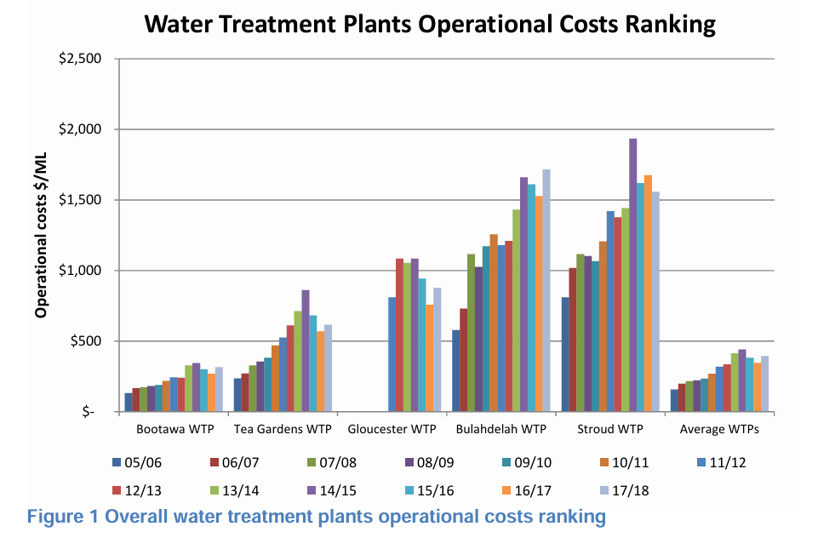
WATER SERVICES: Item 28A Water and Wastewater Treatment Plants Annual Operational Cost Comparisons

Appendix E – Weighted Criteria Matrix
Table 1: Weighted Criteria Matrix
Criteria | Weighting | Option 1- Mechanical Solution (Filter) | Option 2 – Behavioral Change (Paper Towel) | Option 3 – School Awareness Program
Cost of building solution | 20 | 4 – installing in every household has large product + transport cost | 12 - rolling out paper towels and monitoring their success has been estimated to have a relatively low upfront cost, then no ongoing costs. | 4 – This solution requires less cost when compared to mechanical fittings.  Labour costs will be the major cost associated with this.
Time to build solution | 10 | 4.5 – building filter in large quantity could be quick once designed  Immediate reduction in FOG once installed in homes. | 3.5 - distributing paper towels and developing habits will take a few months, and developing the habit has been found to only take 30 days. | 2 - Long time to implement a program into curriculum for many schools.  Take a long time to see results from educating school children
Desirability  WWTPs  Water Authorities | 15 | WWTP:  5 – immediate reduction in FOG loads with no additional operational costs for WWTP | WWTP:  5 - Slow decline in operational costs as behavioural change slowly changes FOG loads | WWTP  5 – There might be no reduction in short term but may make a massive generational change.
Feasibility | 15 | 2.5 - Require infrastructural changes which demand relatively more resources. | 10 – Directly targets the people who can make a change. Relatively easy to measure success. | 2.5 - Program has to be implemented for long term. Measurement of success is very difficult.
Risk of whether it will work | 10 | 4.5 – low risk, physically know it will do the job if people use it | 3.5 – low-medium risk, physically know it will reduce oil if instructions are followed, but risk they are interpreted incorrectly | 2 – high risk, the idea would be for children to influence parents, but this may only happen for a handful of students
Cultural Sensitivity | 10 | 3.5- Unaffected | 3 – based on cultural diets and dishes | 3.5- Unaffected
Scalability | 5 | 1 - Moderate | 2 - Easy | - Easy
Ease of adoption | 5 | 2 - Difficult | 2- Easy | 1 - Moderate
Sponsor Fit  SMEC  Aligns with strategy  Innovative | 10 | 5- SMEC could facilitate a feasibility and design process for the mechanical filter | 2.5- SMEC could act as a consultant for WWTP’s and Councils by suggesting and implementing this solution | 2.5- SMEC could place itself as an environmentally concerned consultant.
TOTAL | 100 | 32 | 43.5 | 24.5

References
Alexandros Maziotis, & Molinos-Senante, M. (2023). A COMPRENHESIVE ECO-EFFICIENCY ANALYSIS OF WASTEWATER TREATMENT PLANTS: ESTIMATION OF OPTIMAL OPERATIONAL COSTS AND GREENHOUSE GAS EMISSIONS. Water Research, 243, 120354–120354. https://doi.org/10.1016/j.watres.2023.120354
Bernstad, A., Davidsson, Å., Tsai, J., Persson, E., Bissmont, M. and la Cour Jansen, J. (2013). Tank-connected food waste disposer systems – Current status and potential improvements. Waste Management, 33(1), pp.193–203. doi:https://doi.org/10.1016/j.wasman.2012.09.022.
Cui, Y., Hao, P., Liu, B., & Meng, X. (2017). Effect of traditional Chinese cooking methods on fatty acid profiles of vegetable oils. Food Chemistry, 233, 77-84.
de Haas, D., Appleby, G., Charakos, G., & Dinesh, N. (2018). Benchmarking energy use for wastewater treatment plants. Water e-Journal, 3(2). https://doi.org/10.21139/wej.2018.023
Eastern Treatment Plant | Melbourne Water. (n.d.). Www.melbournewater.com.au. https://www.melbournewater.com.au/water-and-environment/water-management/sewerage/eastern-treatment-plant
Eco Guardians. (n.d.). Water treatment. https://www.ecoguardians.com.au/services/water-treatment
Fatberg fighting message hits home as blockages fall by a quarter | unitracc.com. (2017). Unitracc.com. https://www.unitracc.com/e-journal/news-and-articles/fatberg-fighting-message-hits-home-as-blockages-fall-by-a-quarter.
Friedler, E. (2004). Quality of Individual Domestic Greywater Streams and its Implication for On-Site Treatment and Reuse Possibilities. Environmental Technology, 25(9), 997–1008. https://doi.org/10.1080/09593330.2004.9619393
Gertz, C., Klostermann, S., & Kochhar, S. P. (2000). Testing and comparing oxidative stability of vegetable oils and fats at frying temperature. European Journal of Lipid Science and Technology, 102(8‐9), 543-551.
Ouchon, P. B., Aguilera, J. M., & Pyle, D. L. (2003). Structure oil‐absorption relationships during deep‐fat frying. Journal of Food science, 68(9), 2711-2716.
Population and dwellings | City of Whitehorse | Community profile. (2023). Profile.id.com.au.https://profile.id.com.au/whitehorse/population
Pu, G., Lu, S., Zheng, M., Huang, J., & Cheng, G. (2019). Study on the Use of Cooking Oil in Chinese Dishes. International Journal of Environmental Research and Public Health, 16(18), 3367. https://doi.org/10.3390/ijerph16183367
Pu, G., Zheng, M., Lu, S., & Huang, J. (2019). Study on the Use of Cooking Oil in Chinese Dishes. International journal of environmental research and public health, 16(18), 3367. https://doi.org/10.3390/ijerph16183367
Sharma, A, Grant, AL, Grant, T, Pamminger, F & Opray, L (2009), Environmental and Economic Assessment of Urban Water Services for a Greenfield Development, Environmental Engineering Science, Vol. 26, No. 5, pp. 921-34.
Thorpe, G. (2024, July 31). South West Water “ups ante” on fatbergs. Bbc.com; BBC News. https://www.bbc.com/news/articles/c250lq0vz1no

